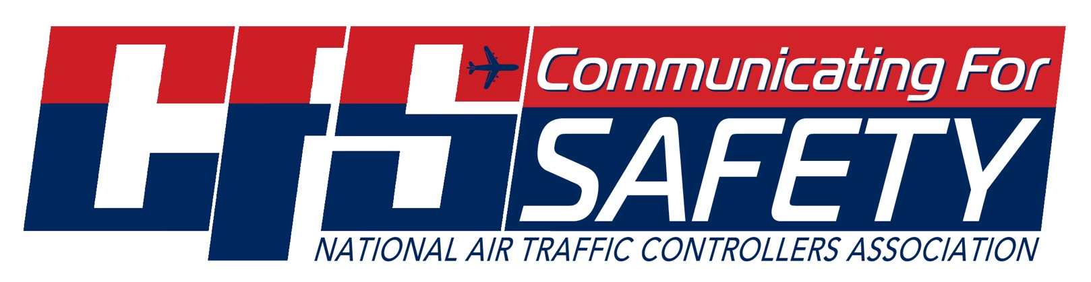

Date:

To: *(Manager)*

From: *(You)*

Re: Communicating for Safety 2024 (September 16-18, 2024)

Las Vegas, NV

This memorandum serves as a request for a release on excused absence in order to attend the 2024 Communicating for Safety Conference.

My request for release on excused absence includes the following dates: ___________________________. This request is made in accordance with (*Choose One*)

Article 29 Section 7 of the ATCS CBA

Article 29 Section 6 of the Consolidated CBA

Article 29 Section 6 of the Multi-Units CBA.

Sincerely,

Received By: _____________________________ Date: _________________